REAGEN™

Non-Esterified Fatty Acids (NEFA) Assay Kit
RNN89001

Product Description

REAGE N™ Non-Esterified Fatty Acids (NEFA) Assay Kit is a plate-based colorimetric enzymatic assay for the quantitative determination of non-esterified fatty acids (NEFA) in serum samples.
The kit uses a spectrophotometric assay to detect non-esterified fatty acids directly from serum samples, enabling researchers to detect non-esterified fatty acids levels in animal serum and othertissue matrices such as urine and ascites.
The unique features of the kit are:
- High sensitivity and wide linear range (0–4mmol/L).
- A rapid (10minute) and robust enzyme-based assay which does not require expensive instrumentation.
- High reproducibility.

Introduction
Non-esterified fatty acidsare the major component of triglycerides, which consist of three fatty acids linked to a glycerol backbone.NEFA is considered as a biomarker of negative energy balance. Low concentrations of NEFAarefound in the blood of healthy animals.Increased concentration of NEFA in blood indicates break down of lipolysis, which happens when the supply of glucose is insufficient to meet energy needs.Therefore, the measurement of NEFA is essential for reducing the risk of gastrointestinal (displaced abomasum), metabolic (clinical ketosis), and infectious (e.g. metritis) diseases.
REAGEN™ Non-Esterified Fatty Acids (NEFA) Assay Kit is a simple, accurateand automation-compatible method for measuring NEFA levels in serum samples. The kit is based on the reaction of NEFA in serum with ATP and Coenzyme A (CoA)in the presence of acyl-CoA synthetase (ASC) to form acyl-CoA, AMP and PPi. The acyl-CoA is then oxidized by acyl-CoA oxidase (ACOD) to produce H2O2. The presence of H2O2 and peroxidase (POD) allows 4-aminoantipyrine to react with 3-methyl-N-ethyl-N-(β-hrdroxyenthyl)-aniline (MEHA) to form a purple color. Theabsorption of this color is measured at 550nm,and its intensity isdirectly proportional to the NEFA concentration.
The kit contains sufficient materials to rapidly test 42 serum samples in duplicate, as well as a control solution containing NEFA standard (4mmol/L) which can be used to calibrate the assay.

Procedure Overview
After preparing the sera, the assay is performed by adding NEFA Reagent A and Reagent B into microplate wells containing 4µL sera. After a 10 minute incubation at room temperature, the absorbance of each well at 550nm is measured by a plate reader. The concentration of NEFA in each sample is then directly determined from 550nm absorbance.

Kit Contents, Storage and Shelf Life

REAGEN™ Non-Esterified Fatty Acid (NEFA) Assay Kit has the capacity for 96 determinations or testing of 42 samples in duplicate (using 12 wells for standards). Store the kit at 4°C. The shelf life is 6 months after receipt when the kit is properly stored.

Kit Contents | Amount | Storage
Microtiter Plate | 1 | 4°C–30°C
NEFAStandard | 1 mL | 4ºC
NEFA Reagent A | 5vials | 4ºC
NEFA Reagent B | 2 vials | 4ºC
Standard Diluent | 1.5 mL | 4ºC

Required Materials Not Provided With the Kit
- Microtiter plate reader (550 nm)
- Centrifuge to prepare serum samples
- Deionized or distilled water
- 1.5ml microfuge tubes
- 10, 20, 100 and 1000 μL pipettes
- Multi-channel pipette (Optional)

Warnings and Precautions
REAGEN strongly recommends that you read the following warnings and precautions to ensure your full awareness of the techniques and other details you should pay close attention to when running the assays. Periodically, optimizations and revisions are made to the kit and manual. Therefore, it is important to follow the protocol that comes with the kit. If you need further assistance, you may contact your local distributor.
- Add standards to plate only in order from low concentration to high concentration, as this will minimize the risk of compromising the standard curve.
- Anticoagulants such as fluoride and oxalate will result in false low values.
- The assay is not influenced by hemoglobin values up to 200mg/dl or by bilirubin levels up to 10mg/dl.
- Interference from grossly hemolyzed specimens is correctable by use of a serum/plasma blank.

SAMPLE PREPARATION
- Carefully prepare at least 15 µL of sera using standard production procedure (if determinations are performed in singlet then 8 µL is sufficient). Any specimen containing heparin is unsuitable for this test.
2. Serum or plasma NEFA is reported stable for 7 days when stored at 4°C and for 3 weeks if frozen.
Note:
1. Samples with values above 4mmol/L should be diluted 1:1 with saline (0.9% NaCl)and re-tested. Multiply results by two.
2. Grossly lipemic serums require a sample blank. Add 5 µLof sample to 250 µL saline, mix, and read the absorbance against water. Subtract this reading value from the absorbance of each serum sample to obtain the corrected reading. PARATION
INOGANIC PHOSPHORUSDETECTION TEST PCOL

INOGANIC PHOSPHORUS DETERMINATION TEST PROTOCOL
Setup
Allow reagent and standard come to room temperature (25°C) before use.Turn on the plate reader and allowthelamp to warm up. Adjust the wavelength of the plate reader to 550nm.
Reagent Preparation
Preparation of NEFA Reagent A and NEFA Reagent B
To reconstitute the NEFA Reagent A, add exactly 5mL of distilled waterto the NEFA Reagent A.
To reconstitute the NEFA Reagent B, add exactly 5mL of distilled waterto the NEFA Reagent B. Mix by swirling or inverting the bottle 10 -12 timesuntil the contents are completely dissolved. Allow contents to dissolve for 5 minutes at room temperature.
IMPORTANT: The reconstituted NEFA Reagent A and NEFA Reagent B can be left at room temperature for short periods (up to 4 hours) prior to use. Between uses, the reconstituted NEFA Reagent A and NEFA Reagent B should be stored at 4C (for up to 30 days).
Preparation of Total ProteinControl Dilutions for Standard Curve
1. Label 6microfuge tubes: 1, 2, 3, 4, 5, 6.
2. Dilute the NEFAStandard using Standard Diluentas described in the table below. Afterdilution, briefly mix each tube.
Tube # | Volume NEFA Standard (4 mmol/L) | Volume Standard Diluent | NEFAConcentration (mmol/L)
1 | 0 µL | 80µL | 0
2 | 10µL | 70 µL | 0.5
3 | 20µL | 60µL | 1
4 | 40µL | 40µL | 2
5 | 60µL | 20µL | 3
6 | 80µL | 0 µL | 4
- Use 4µL of each diluted standard per reaction (see below).

Sample Test Procedure
1. Add 4µL of each sample or standard (in duplicate) to the microplate wells.
2. Add 225µL of NEFAreagent Ato the wells.
3. Add 75µL of NEFAreagent B to the wells. Allow plate to stand for at 10minutesat room temperature.
4. Measure the absorbance of each wellat 550nm.

NEFA Concentration Calculation
There is a linear relationship between the concentration of NEFAin the sample and absorbance at 550nm. Therefore, a standard curve used to calculate the NEFAconcentration in sera samples can be constructed by plotting the mean corrected absorbance values for each of the diluted NEFAstandards as a function of inorganic phosphorus concentration. The standard curve provides a reference for the linearrange of the assay.

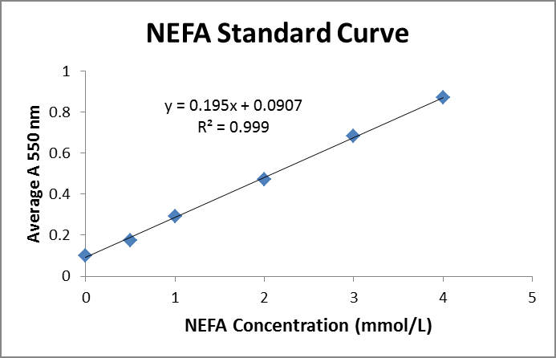

REAGEN LLC
Add.: 102CommerceDr.Unit8,Moorestown,NJ08057
Tel.:856-727-0250 FAX.:856-727-0251
E-mail:reagenkits@gmail.com reagenllc@gmail.com
Web.:www.reagen.us

