REAGEN™

Ciprofloxacin ELISA Test Kit
RND99020

Product Description
REAGEN™Ciprofloxacin ELISA Test Kit provides a competitive enzyme mmunoassay for the quantitative analysis of Ciprofloxacin in feed, meat,tissue, milk,milk powder, serum and urine.
The unique features of the kit are:
- Rapid, high recovery (75 - 95%), and cost-effective extraction methods for various samples.
- High sensitivity (0.35 ng/g or ppb) and low detection limit (0.525 ng/g or ppb) for feed samples.
- High reproducibility.
- A quick ELISA assay (less than 1.5 hour regardless of number of samples).

Procedure Overview
The method is based on a competitive colorimetric ELISA assay. The ciprofloxacin antibody has been coated in the plate wells. During the analysis, sample is added along with the ciprofloxacin-horseradish peroxidase (Ciprofloxacin-HRP) conjugate. If the ciprofloxacin residue is present in the sample, it will compete for the ciprofloxacin antibody, thereby preventing the Ciprofloxacin-HRP from binding to the antibody attached to the well. The resulting color intensity, after addition of the HRP substrate (TMB), has an inverse relationship with the ciprofloxacin residue concentration in the sample.

Kit Contents, Storage and Shelf Life
REAGEN™ Ciprofloxacin ELISA Test Kit has the capacity for 96 determinations or testing of 42 samples in duplicate (assuming 12 wells for standards). Return any unused microwells to the foil bag and reseal them with the desiccant provided in the original package. Store the kit at 2-8°C. The shelf life is 12 months when the kit is properly stored.

Kit Contents | Amount | Storage
Ciprofloxacin-coated Plate | 96-well plate (8 wells x 12 strips) | 2-8°C
Ciprofloxacin Standards:  Negative control (white cap tube)  0.35 ng/mL (yellow cap tube)  1.0ng/mL (orange cap tube)  2.5ng/mL (pink cap tube)  7.5ng/mL (purple cap tube)  22.5 ng/mL (blue cap tube)  100ng/mL (spiking, optional, red cap tube) | 1.0mL  1.0mL  1.0mL  1.0mL  1.0mL  1.0mL  1.0mL | 2-8°C
Ciprofloxacin-HRP | 15mL | 2-8°C
10X Sample Extraction Buffer | 25mL | 2-8°C
20X Wash Solution | 30mL | 2-8°C
TMB Substrate | 12mL | 2-8°C
Stop Buffer | 15mL | 2-8°C
Enro/Cipro Extraction Buffer | 10mL | 2-8°C
Sample Balance Buffer | 1.6mL | 2-8°C
If you are not planning to use the kit for over 3 months, store Ciprofloxacin standards, Ciprofloxacin-HRP at -20°C or in a freezer.

Sensitivity
Sample Type | Detection Limit (ng/g or ppb)(Organic Reagent Extraction Method) | Detection Limit (ng/g or ppb)(Rapid Method)
Feed | 0.525 | 3.5
Meat/Liver/Kidney/Fish/Shrimp | 0.525 | 3.5
Milk/powder | 0.7 | 1.75
Serum | 0.7 | 1.75
Urine | 0.7 | 1.75

Specificity
Analytes | Cross-Reactivity (%)
Ciprofloxacin | 100
Danofloxacin | 33
Enoxacin | 15
Pipemidic acid | 13
Ofloxacin | 8
Benofloxacin | 3
Oxolin acid | 4
Nalidixic acid | 2

Required Materials Not Provided With the Kit
- Microtiter plate reader (450 nm)
- Incubator
- Tissue Mixer (e.g. Omni TissueMaster Homogenizer)
- Vortex mixer (e.g. Gneie Vortex mixer from VWR)
- 10, 20, 100 and 1000 μL pipettes
- Multi-channel pipette: 50-300 μL (Optional)

Warnings and Precautions
- The standards contain Ciprofloxacin. Handle with particular care.
- Do not use the kit past the expiration date.
- Do not intermix reagents from different kits or lots except for components with the same part No’s within their expiration dates. HRP CONJUGATES AND PLATES ARE KIT-AND LOT-SPECIFIC.
- Try to maintain a laboratory temperature of 20°–25°C (68°–77°F). Avoid running assays under or near air vents, as this may cause excessive cooling, heating and/or evaporation. Also, do not run assays in direct sunlight, as this may cause excessive heat and evaporation. Cold bench tops should be avoided by placing several layers of paper towel or some other insulation material under the assay plates during incubation.
- Make sure you are using only distilled or deionized water since water quality is very important.
- When pipetting samples or reagents into an empty microtiter plate, place the pipette tips in the lower corner of the well, making contact with the plastic.
- Incubations of assay plates should be timed as precisely as possible. Be consistent when adding standards to the assay plate. Add your standards first and then your samples.
- Add standards to plate only in the order from low concentration to high concentration as this will minimize the risk of compromising the standard curve.
- Always refrigerate plates in sealed bags with a desiccant to maintain stability. Prevent condensation from forming on plates by allowing them equilibrate to room temperature (20 – 25°C / 68 – 77°F) while in the packaging.

SAMPLE PREPARATION

Be sure samples are properly stored. In general, samples should be refrigerated at 2-4°C for no more than 1-2 days. Freeze samples to a minimum of -20°C if they need to be stored for a longer period. Frozen samples can be thawed at room temps (20 – 25°C / 68 – 77°F) or in a refrigerator before use.
  - 1. Preparation of 1X Sample Extraction Buffer:
Mix 1 volume of 10X Sample Extraction Buffer with 9 volumes of distilled water.

  - 2. Preparation of 35% Methanol/Sample Extraction Buffer
Mix 6.5 volumes of 1X Sample Extraction Buffer with 3.5 volumes of 100% methanol

  - 3. Preparation of 98% Methanol/Enro/Cipro Extraction Buffer
Mix 2 volumes of Enro/Cipro Extraction Buffer with 98 volumes of 100% methanol

Feed
Rapid Method
- To a reasonable amount of sample, add 5 times the amount of 70% methanol (e.g. 1 g of sample + 5 mL of 70% methanol); homogenize the sample with a suitable mixer.
- Take out 1.5 mL of the homogenized sample and centrifuge for 5 minutes at 4,000 x g at room temperature (20 –25°C / 68 – 77°F).
- Transfer 0.5 mL of the supernatant to a tube, add 0.5 mL of 1X Sample Extraction Buffer, and mix well.
- Use 50 µL of the sample per well for the assay

Note: Dilution factor: 10.
Organic Reagent Extraction Method
- Homogenize the feed sample with a suitable mixer.
- Weigh out 1.0 g of the homogenized sample and add 3 mL of 98% methanol/Enro/Cipro Extraction Buffer.
- Vortex vigourously for 2 minutes individually then 10 minutes at half speed using a multitube vortexer.
- Centrifuge for 10 minutes at 4,000 x g at room temperature (20 – 25°C / 68 – 77°F).
- Transfer 1 mL of the supernatant to a tube and use a rotary evaporator to dry the sample in a 50-60°C water bath under reduced pressure. Alternatively, the sample can be dried by blowing nitrogen gas in a 50-60°C water bath.
- Add 0.5 mL of 35% Methanol/Sample Extraction Buffer and vortex gently for 30 seconds then add 1ml of n-hexanes and vortex individually for 2 minutes at maximum speed for 2 minutes.
- Centrifuge for 10 minutes at 4,000 x g at room temperature. Discard the upper hexane layer.
- Transfer 150 µL of lower aqueous layer to a new tube, add 15 µL of Sample Balance Buffer and mix well. Use 50 µL of sample per well for the assay.
Note: Dilution factor: 1.5.

Meat/Liver/Kidney/Fish/Shrimp
Rapid Method
- Remove fat from the sample. Homogenize the sample with a suitable mixer.
- Weigh out 1.0 g of the homogenized sample and add 4 mL of 70% methanol.
- Vortex for 10 minutes at maximum speed.
- Centrifuge for 5 minutes at 4,000 x g at room temperature (20 –25°C/ 68 – 77°F).
- Transfer 0.5 mL of the supernatant to a tube, add 0.5 mL of 1X Sample Extraction Buffer, and mix well.
- Use 50 µL for the assay.
Note: Dilution factor: 10.
Organic Reagent Extraction Method
- Remove fat from the sample. Homogenize the sample with a suitable mixer.
- Weigh out 1.0 g of the homogenized sample and add 3 mL of 98% methanol/Enro/Cipro Extraction Buffer.
- Vortex vigourously for 2 minutes individually then 10 minutes at half speed using a multitube vortexer.
- Centrifuge for 10 minutes at 4,000 x g at room temperature (20 – 25°C / 68 – 77°F).
- Transfer 1 mL of the supernatant to a tube and use a rotary evaporator to dry the sample in a 50-60°C water bath under reduced pressure. Alternatively, the sample can be dried by blowing nitrogen gas in a 50-60°C water bath.
- Add 0.5 mL of 35% Methanol/Sample Extraction Buffer and vortex gently for 30 seconds then add 1ml of n-hexanes and vortex individually for 2 minutes at maximum speed for 2 minutes.
- Centrifuge for 10 minutes at 4,000 x g at room temperature. Discard the upper hexane layer. In case emulsion happened, remove the upper n-hexane layer and incubate the lower aqueous layer in water bath for 3 min at 80-95°C.
- Transfer 150 µL of lower aqueous layer to a new tube, add 15 µL of Sample Balance Buffer and mix well. Use 50 µL of sample per well for the assay.

Note: Dilution factor: 1.5.

Milk
Rapid Method
- For fat-free milk, take out 200 µL of the milk sample, add 800 µL of 35% Methanol/Sample Extraction Buffer, and mix well. Take 50 µL of the diluted sample per well for the assay.
- For regular milk with fat, centrifuge 1 mL of the milk sample at 4,000 x g for 5 minutes, discard the upper fat layer. Take out 200 µL of the milk sample, add 800 µL of 35% Methanol/Sample Extraction Buffer, and mix well. Take 50 µL of the diluted sample per well for the assay.

Note: Dilution factor: 5.
Organic Reagent Extraction Method
- Weigh out 1.0 g of milk sample and add 3 mL of 98% methanol/Enro/Cipro Extraction Buffer.
- Vortex vigourously for 2 minutes individually then 10 minutes at half speed using a multitube vortexer.
- Centrifuge for 10 minutes at 4,000 x g at room temperature (20 – 25°C / 68 – 77°F).
- Transfer 1 mL of the supernatant to a tube and use a rotary evaporator to dry the sample in a 50-60°C water bath under reduced pressure. Alternatively, the sample can be dried by blowing nitrogen gas in a 50-60°C water bath.
- Add 0.5 mL of 35% Methanol/Sample Extraction Buffer and vortex gently for 30 seconds then add 1ml of n-hexanes and vortex individually for 2 minutes at maximum speed for 2 minutes.
- Centrifuge for 10 minutes at 4,000 x g at room temperature. Discard the upper hexane layer. Transfer 150 µL of lower aqueous layer to a new tube, add 15 µL of Sample Balance Buffer and mix well. Use 50 µL of sample per well for the assay.

Note: Dilution factor: 2.

Milk
Organic Reagent Extraction Method
- Weigh out 1.0 g of milk sample and add 4 mL of 98% methanol/Enro/Cipro Extraction Buffer.
- Vortex vigourously for 2 minutes individually then 10 minutes at half speed using a multitube vortexer.
- Centrifuge for 10 minutes at 4,000 x g at room temperature (20 – 25°C / 68 – 77°F).
- Transfer 1 mL of the supernatant to a tube and use a rotary evaporator to dry the sample in a 50-60°C water bath under reduced pressure. Alternatively, the sample can be dried by blowing nitrogen gas in a 50-60°C water bath.
- Add 0.5 mL of 35% Methanol/Sample Extraction Buffer and vortex gently for 30 seconds then add 1ml of n-hexanes and vortex individually for 2 minutes at maximum speed for 2 minutes.
- Centrifuge for 10 minutes at 4,000 x g at room temperature. Discard the upper hexane layer. Transfer 150 µL of lower aqueous layer to a new tube, add 15 µL of Sample Balance Buffer and mix well. Use 50 µL of sample per well for the assay.
Note: Dilution factor: 2.

Serum/Urine
Rapid Method
- Centrifuge 0.5 mL of serum at 4,000 x g for 5 minutes.
- Take out 0.2 mL of the supernatant, add 0.8 mL of 35% Methanol/Sample Extraction Buffer.
- Use 50 µL per well for the assay.

Note: Dilution factor: 5.
Organic Reagent Extraction Method
- Take out 1.0 mL of serum/urine sample and add 3 mL of 98% methanol/Enro/Cipro Extraction Buffer.
- Vortex vigourously for 2 minutes individually then 10 minutes at half speed using a multitube vortexer.
- Centrifuge for 10 minutes at 4,000 x g at room temperature (20 – 25°C / 68 – 77°F).
- Transfer 1 mL of the supernatant to a tube and use a rotary evaporator to dry the sample in a 50-60°C water bath under reduced pressure. Alternatively, the sample can be dried by blowing nitrogen gas in a 50-60°C water bath.
- Add 0.5 mL of 35% Methanol/Sample Extraction Buffer and vortex gently for 30 seconds then add 1ml of n-hexanes and vortex individually for 2 minutes at maximum speed for 2 minutes.
- Centrifuge for 10 minutes at 4,000 x g at room temperature. Discard the upper hexane layer.
- Transfer 150 µL of lower aqueous layer to a new tube, add 15 µL of Sample Balance Buffer and mix well. Use 50 µL of sample per well for the assay.

Note: Dilution factor: 2.

CIPROFLOXACIN ELISA TEST KIT PROTOCOL

Reagent Preparation
IMPORTANT: All reagents should be brought up to room temperature before use (1 – 2 hours at 20 – 25°C / 68 – 77°F); Make sure you read “Warnings and Precautions” section on page 3. Solutions should be prepared just prior to ELISA test.  All reagents should be mixed by gently inverting or swirling prior to use. Prepare volumes that are needed for the number of wells being run. Do not return the reagents to the original stock tubes/bottles. Using disposable reservoirs when handling reagents can minimize the risk of contamination and is recommended.

- Preparation of 1X Wash Solution
Mix 1 volume of 20X Wash Buffer concentrate with 19 volumes of distilled water.

ELISA Testing Protocol

Label the individual strips that will be used and aliquot reagents as the following example:
Component | Volume per Reaction | 24 Reactions
Ciprofloxacin-HRP | 100 µL | 2.4 mL
1X Wash Solution | 1.0 mL | 24 mL
Stop Buffer | 100 µL | 2.4 mL
TMB Substrate | 100 µL | 2.4 mL

- Add 50 µL of each Ciprofloxacin Standards in duplicate into different wells ( Add standards to plate only in the order from low concentration to high concentration).
- Add 50 µL of each sample in duplicate into different sample wells.
- Add 100 µL of Ciprofloxacin-HRP and mix well by gently rocking the plate manually for 1 minute.
- Incubate the plate for 40 minutes at room temperature (20 – 25°C / 68 – 77°F).
- Wash the plate 3 times with 250 µL 1X Wash Solution. After the last wash, invert the plate and gently tap the plate dry on paper towels (Perform the next step immediately after plate washings. Do not allow the plate to air dry between working steps).
- Add 100 µL of TMB substrate. Time the reaction immediately after adding the substrate.Mix the solution by gently rocking the plate manually for 1 minute while incubating( Do not put any substrate back to the original container to avoid any potential contamination. Any substrate solution exhibiting coloration is indicative of deterioration and should be discarded. Covering the plate while incubating is recommended).
- After incubating for 20 minutes at room temperature (20–25°C / 68–77°F), add 100 µL of Stop Buffer to stop the enzyme reaction.
- Read the plate as soon as possible following the addition of Stop Buffer on a plate reader with 450 nm wavelength ( Before reading, use a lint-free wipe on the bottom of the plate to ensure no moisture or fingerprints interfere with the readings).

Ciprofloxacin Concentration Calculations

A standard curve can be constructed by plotting the mean relative absorbance (%) obtained from each reference standard against its concentration in ng/mL on a logarithmic curve.

Relative absorbance (%) =

Use the mean relative absorbance values for each sample to determine the corresponding concentration of the tested drug in ng/mL from the standard curve.

The following figure is a typical Ciprofloxacin standard curve. The sample detection and quantification limit are calculated as below.

Sample detection limit = (0.35 ng/g or ppb) x (dilution factor)
Sample quantification limit = (1.0 ng/g or ppb) x (dilution factor)

For example, the dilution factor for meat sample is 1.5 (Organic Reagent Extraction Method ), therefore, the detection limit for meat sample is 0.525 ng/g or ppb (0.35 ng/g x dilution factor 1.5) and the quantification limit is 1.5 ng/g or ppb (1 ng/g x dilution factor 1.5).
Ciprofloxacin Standard Curve

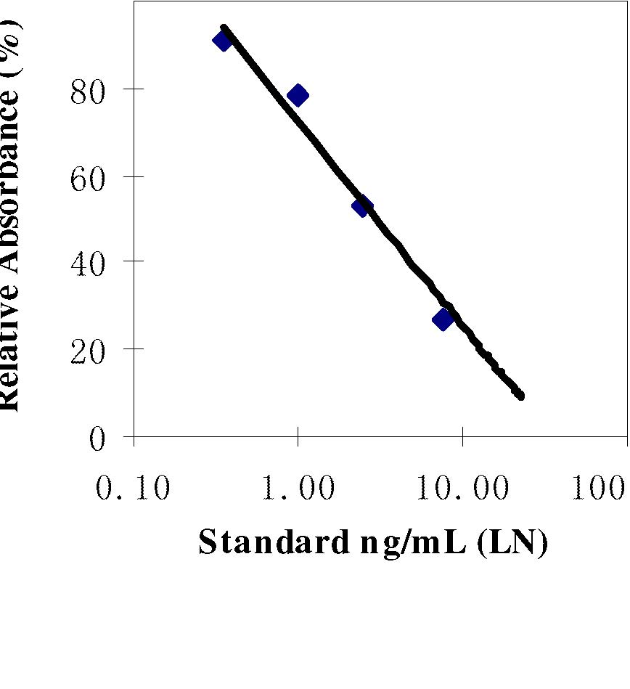
REAGEN LLC
Add.: 102CommerceDr.Unit8,Moorestown,NJ08057
Tel.:856-727-0250 FAX.:856-727-0251
E-mail:reagenkits@gmail.com reagenllc@gmail.com
Web.:www.reagen.us

